JUnit Testing Exercises
Exercise 1: Setting Up JUnit Scenario:
You need to set up JUnit in your Java project to start writing unit tests.
Created the project and the test class

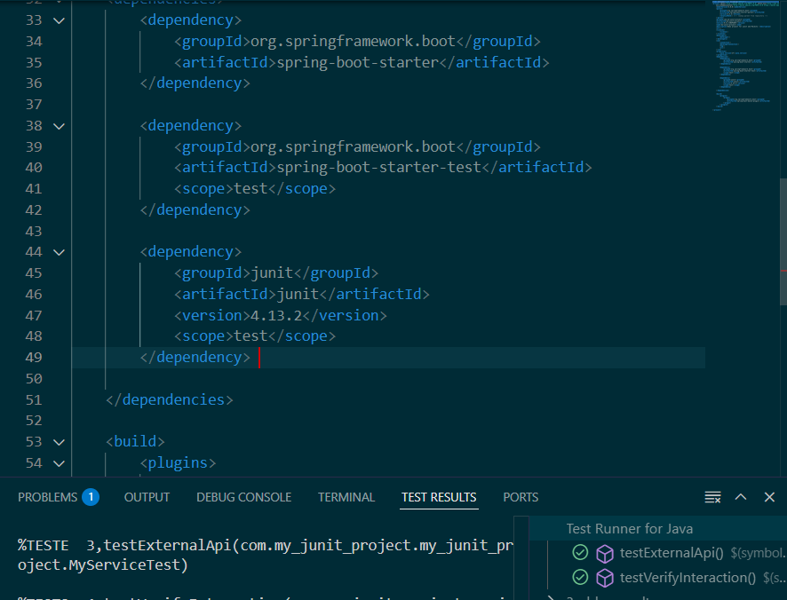
Exercise 2: Writing Basic JUnit Tests Scenario: You need to write basic JUnit tests for a simple Java class. Steps: 1. Create a new Java class with some methods to test. 2. Write JUnit tests for these methods.
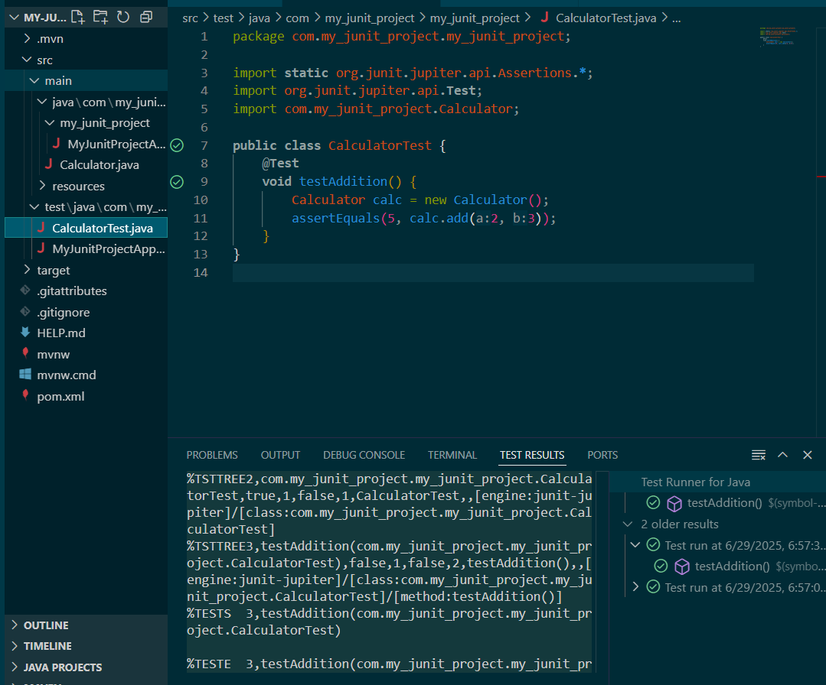

Exercise 3: Assertions in JUnit Scenario: You need to use different assertions in JUnit to validate your test results.
Steps: 1. Write tests using various JUnit assertions.
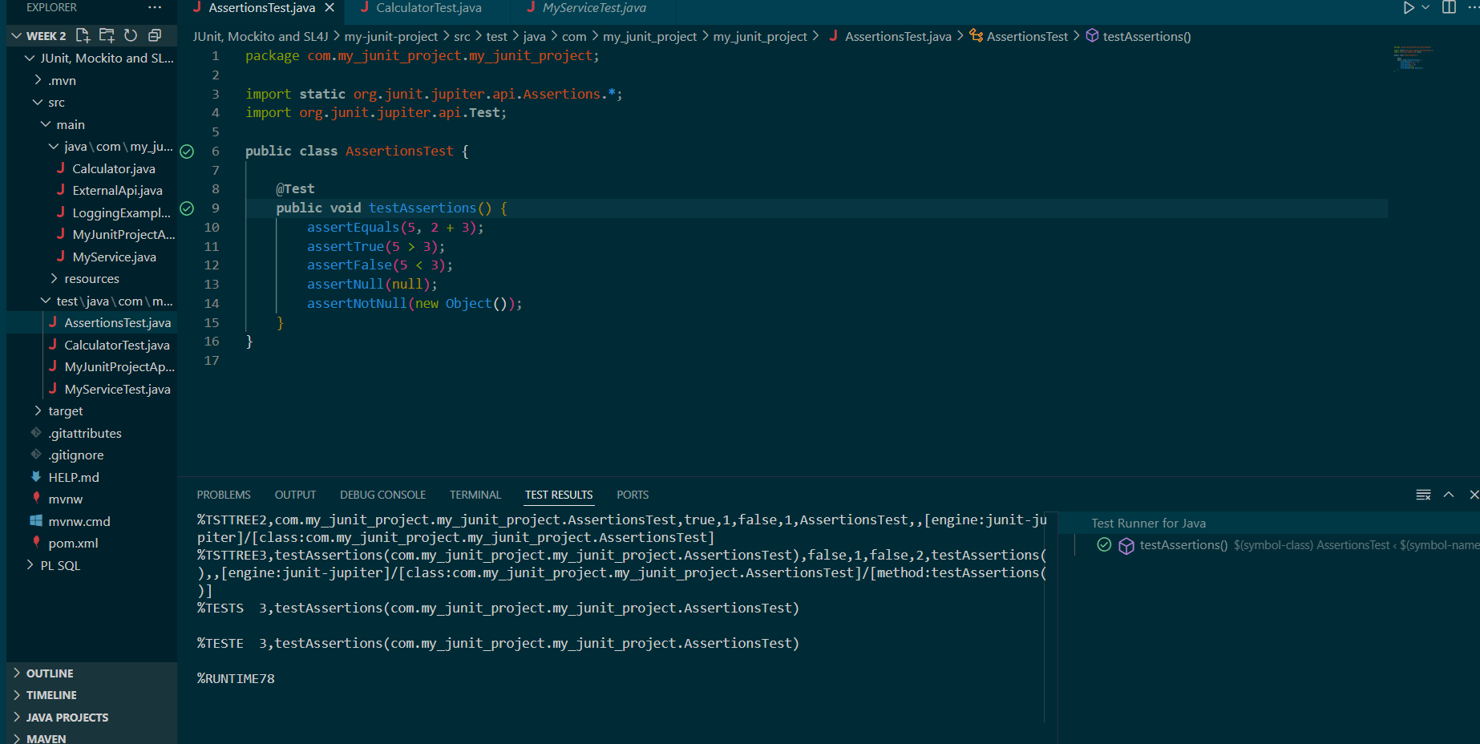

Exercise 4: Arrange-Act-Assert (AAA) Pattern, Test Fixtures, Setup and Teardown Methods in JUnit Scenario: You need to organize your tests using the Arrange-Act-Assert (AAA) pattern and use setup and teardown methods.
Steps: 1. Write tests using the AAA pattern. 2. Use @Before and @After annotations for setup and teardown methods.
